

BIG DATA ANALYTICS

**INTERNAL ASSIGNMENT**

**BIG DATA APPLICATION IN:**

# Performing MapReduce on The Abstracts

The following REPORT has been worked upon by the following students pursuing their 3rd year of BBA (BA) at GITAM UNIVERSITY:

# Group No: 2

|  |  |  |
| --- | --- | --- |
| **NAME OF STUDENT** | **Reg.No.** | **DIVISION** |
| **Adari Lohit** | 121913901040 | Business Analytics |

**Submitted to: Prof. Kamakshaiah**

**Word count: words (excluding cover page and bibliography)**

**TABLE OF CONTENTS**

DECLARATION 3

INTRODUCTION 4

HADOOP COMPONENTS 5

DATA ANALYSIS USING HADOOP 8

ABOUT THE INDUSTRY 12

REVIEW OF LITERATURE 15

CONCLUSION 18

BIBLIOGRAPHY 19

**DECLARATION**

We hereby declare that the project work entitled “**Big Data in Finance”** Submitted towards partial fulfillment of requirements for the award of Bachelor of Business Administration in Business Analytics. Authentic record of genuine work done under the guidance of Kamakshaiah Musunuru, Associate Professor, Department of Business Analytics, Gandhi Institute of technology and Management, Visakhapatnam.

**Date: 14/04/2022**

**INTRODUCTION**

Big data in finance refers to large, diverse (structured and unstructured) and complex sets of data that can be used to provide solutions to long-standing business challenges for financial services and banking companies around the world. The term is no longer just confined to the realm of technology but is now considered a business imperative. It is increasingly leveraged by financial services firms to transform their processes, their organizations, and the entire industry.

Big data refers to data that is so large, fast or complex that it’s difficult or impossible to process using traditional methods. The act of accessing and storing large amounts of information for analytics has been around for a long time. But the concept of big data gained momentum in the early 2000s when industry analyst Doug Laney articulated the now-mainstream definition of big data as the three V’s

Volume. Organizations collect data from a variety of sources, including transactions, smart (IoT) devices, industrial equipment, videos, images, audio, social media and more. In the past, storing all that data would have been too costly – but cheaper storage using data lakes, Hadoop and the cloud have eased the burden.

Velocity. With the growth in the Internet of Things, data streams into businesses at an unprecedented speed and must be handled in a timely manner. RFID tags, sensors and smart meters are driving the need to deal with these torrents of data in near-real time.

Variety. Data comes in all types of formats – from structured, numeric data in traditional databases to unstructured text documents, emails, videos, audios, stock ticker data and financial transactions.

**HADOOP AND ITS COMPONENTS**

Hadoop is a framework that uses distributed storage and parallel processing to store and manage big data. It is the software most used by data analysts to handle big data, and its market size continues to grow. There are three components of Hadoop:

1. Hadoop HDFS - Hadoop Distributed File System (HDFS) is the storage unit.

2. Hadoop MapReduce - Hadoop MapReduce is the processing unit.

3. Hadoop YARN - Yet Another Resource Negotiator (YARN) is a resource management unit.

Hadoop HDFS:

Data is stored in a distributed manner in HDFS. There are two components of HDFS - name node and data node. While there is only one name node, there can be multiple data nodes.

HDFS is specially designed for storing huge datasets in commodity hardware. An enterprise version of a server costs roughly $10,000 per terabyte for the full processor. In case you need to buy 100 of these enterprise version servers, it will go up to a million dollars.

Hadoop enables you to use commodity machines as your data nodes. This way, you don’t have to spend millions of dollars just on your data nodes. However, the name node is always an enterprise server.

Features of HDFS

• Provides distributed storage

• Can be implemented on commodity hardware

• Provides data security

• Highly fault-tolerant - If one machine goes down, the data from that machine goes to the next machine

Master and Slave Nodes

Master and slave nodes form the HDFS cluster. The name node is called the master, and the data nodes are called the slaves.

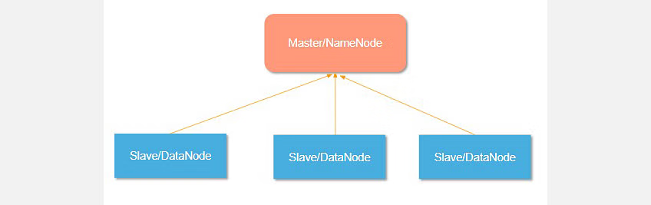

The name node is responsible for the workings of the data nodes. It also stores metadata.

The data nodes read, write, process, and replicate the data. They also send signals, known as heartbeats, to the name node. These heartbeats show the status of the data node.

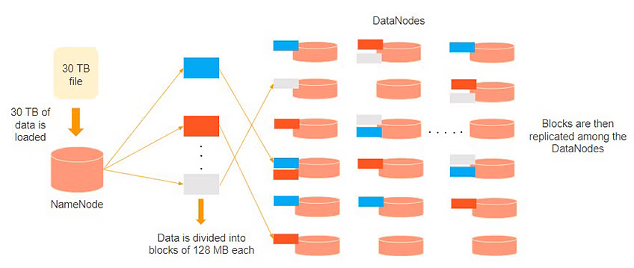

Consider that 30TB of data is loaded into the name node. The name node distributes it across the data nodes, and this data is replicated among the data notes. You can see in the image above that the blue, grey, and red data are replicated among the three data nodes.

Replication of the data is performed three times by default. It is done this way, so if a commodity machine fails, you can replace it with a new machine that has the same data.

Hadoop Map reduce:

Hadoop MapReduce is the processing unit of Hadoop. In the MapReduce approach, the processing is done at the slave nodes, and the result is sent to the master node.

A data containing code is used to process the entire data. This coded data is usually very small in comparison to the data itself. You only need to send a few kilobytes worth of code to perform a heavy-duty process on computers.

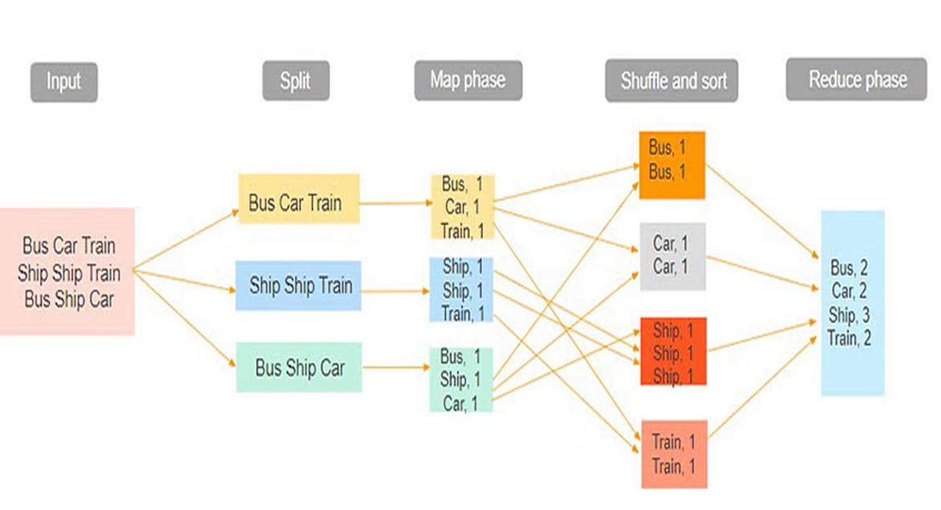

The input dataset is first split into chunks of data. In this example, the input has three lines of text with three separate entities - “bus car train,” “ship ship train,” “bus ship car.” The dataset is then split into three chunks, based on these entities, and processed parallel.

In the map phase, the data is assigned a key and a value of 1. In this case, we have one bus, one car, one ship, and one train.

These key-value pairs are then shuffled and sorted together based on their keys. At the reduce phase, the aggregation takes place, and the final output is obtained.

Hadoop YARN:

Hadoop YARN stands for Yet Another Resource Negotiator. It is the resource management unit of Hadoop and is available as a component of Hadoop version 2.

• Hadoop YARN acts like an OS to Hadoop. It is a file system that is built on top of HDFS.

• It is responsible for managing cluster resources to make sure you don't overload one machine.

• It performs job scheduling to make sure that the jobs are scheduled in the right place

Suppose a client machine wants to do a query or fetch some code for data analysis. This job request goes to the resource manager (Hadoop Yarn), who is responsible for resource allocation and management.

In the node section, each of the nodes has its node managers. These node managers manage the nodes and monitor the resource usage in the node. The containers contain a collection of physical resources, which could be RAM, CPU, or hard drives. Whenever a job request comes in, the app master requests the container from the node manager. Once the node manager gets the resource, it goes back to the Resource Manager.

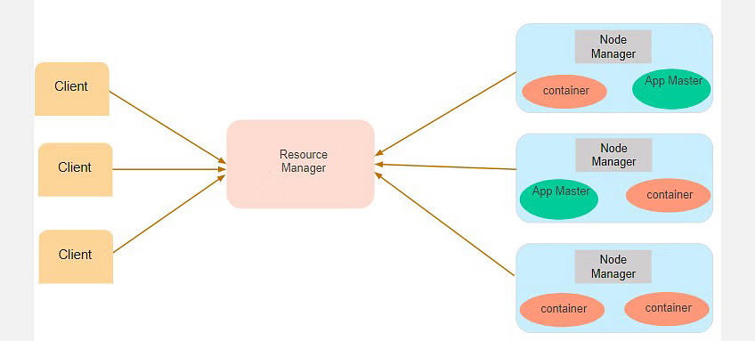

DATA ANALYSIS USING HADOOP

Big Data is unwieldy because of its vast size and needs tools to efficiently process and extract meaningful results from it. Hadoop is an open-source software framework and platform for storing, analyzing and processing data. This article is a beginner’s guide to how Hadoop can help in the analysis of Big Data.

Big Data is a term used to refer to a huge collection of data that comprises both structured data found in traditional databases and unstructured data like text documents, video and audio. Big Data is not merely data but also a collection of various tools, techniques, frameworks and platforms. Transport data, search data, stock exchange data, social media data, etc, all come under Big Data.

Technically, Big Data refers to a large set of data that can be analyzed by means of computational techniques to draw patterns and reveal the common or recurring points that would help to predict the next step—especially human behavior, like future consumer actions based on an analysis of past purchase patterns.

Big Data is not about the volume of the data, but more about what people use it for. Many organizations like business corporations and educational institutions are using this data to analyze and predict the consequences of certain actions. After collecting the data, it can be used for several functions like:

• Cost reduction

• The development of new products

• Making faster and smarter decisions

• Detecting faults

Today, Big Data is used by almost all sectors including banking, government, manufacturing, airlines and hospitality.

There are four main libraries in Hadoop.

1. Hadoop Common: This provides utilities used by all other modules in Hadoop.

2. Hadoop MapReduce: This works as a parallel framework for scheduling and processing the data.

3. Hadoop YARN: This is an acronym for Yet Another Resource Navigator. It is an improved version of MapReduce and is used for processes running over Hadoop.

4. Hadoop Distributed File System – HDFS: This stores data and maintains records over various machines or clusters. It also allows the data to be stored in an accessible format.

HDFS sends data to the server once and uses it as many times as it wants. When a query is raised, Name Node manages all the Data Node slave nodes that serve the given query. Hadoop MapReduce performs all the jobs assigned sequentially. Instead of MapReduce, Pig Hadoop and Hive Hadoop are used for better performances.

Hadoop Tools

1. Apache Spark

Apache spark is an open-source processing engine that is designed for ease of analytics operations. It is a cluster computing platform that is designed to be fast and made for general purpose uses. Spark is designed to cover various batch applications, Machine Learning, streaming data processing, and interactive queries.

Features of Spark:

In memory processing

Tight Integration Of component

Easy and In-expensive

The powerful processing engine makes it so fast

Spark Streaming has high level library for streaming process

2. Map Reduce

MapReduce is just like an Algorithm or a data structure that is based on the YARN framework. The primary feature of MapReduce is to perform the distributed processing in parallel in a Hadoop cluster, which Makes Hadoop working so fast Because when we are dealing with Big Data, serial processing is no more of any use.

Features of Map-Reduce:

• Scalable

• Fault Tolerance

• Parallel Processing

• Tunable Replication

• Load Balancing

3. Apache Hive

Apache Hive is a Data warehousing tool that is built on top of the Hadoop, and Data Warehousing is nothing but storing the data at a fixed location generated from various sources. Hive is one of the best tools used for data analysis on Hadoop. The one who is having knowledge of SQL can comfortably use Apache Hive. The query language of high is known as HQL or HIVEQL.

Features of Hive:

• Queries are like SQL queries.

• Hive has different storage type HBase, ORC, Plain text, etc.

• Hive has an in-built function for data-mining and other works.

• Hive operates on compressed data that is present inside Hadoop Ecosystem.

4. Apache Pig

This Pig was Initially developed by Yahoo to get ease in programming. Apache Pig has the capability to process an extensive dataset as it works on top of Hadoop. Apache pig is used for analyzing more massive datasets by representing them as dataflow. Apache Pig also raises the level of abstraction for processing enormous datasets. Pig Latin is the scripting language that the developer uses for working on the Pig framework that runs on Pig runtime.

Features of Pig:

• Easy To Programme

• Rich set of operators

• Ability to handle various kinds of data

• Extensibility

5. HBase

HBase is nothing but a non-relational, NoSQL distributed, and column-oriented database. HBase consists of various tables where each table has multiple numbers of data rows. These rows will have multiple numbers of column families, and this column family will have columns that contain key-value pairs. HBase works on the top of HDFS (Hadoop Distributed File System). We use HBase for searching small size data from the more massive datasets.

Features of HBase:

• HBase has Linear and Modular Scalability

• JAVA API can easily be used for client access

• Block cache for real time data queries

ABOUT THE INDUSTRY

Instead of simply analyzing stock prices, big data can now take into account political and social trends that may affect the stock market. Machine learning monitors trends in real-time, allowing analysts to compile and evaluate the appropriate data and make smart decisions.

**1. Real-time stock market insights**

Big data is completely revolutionizing how stock markets worldwide are functioning and how investors are making their investment decisions. Machine learning – the practice of using computer algorithms to find patterns in massive amounts of data – is enabling computers to make accurate predictions and human-like decisions when fed data, executing trades at rapid speeds and frequencies.

The business archetype monitors stock trends in real-time. It incorporates the best possible prices, allowing analysts to make smart decisions and reduce manual errors due to behavioral influences and biases. In conjunction with big data, algorithmic trading is thus resulting in highly optimized insights for traders to maximize their portfolio returns.

**2. Big data analytics in financial models**

Big data analytics presents an exciting opportunity to improve predictive modeling to better estimate the rates of return and outcomes on investments. Access to big data and improved algorithmic understanding results in more precise predictions and the ability to mitigate the inherent risks of financial trading effectively.

**3. Customer analytics**

Today, customers are at the heart of the business around which data insights, operations, technology, and systems revolve. Thus, big data initiatives underway by banking and financial markets companies focus on customer analytics to provide better service to customers.

Companies are trying to understand customer needs and preferences to anticipate future behaviors, generate sales leads, take advantage of new channels and technologies, enhance their products, and improve customer satisfaction.

Thus, by effectively cultivating meaningful relationships with their customers and improving their ability to anticipate customer preferences, financial markets organizations can deliver new customer-centric products and services to seize market opportunities quickly.

For example, the Oversea-Chinese Banking Corporation (OCBC) analyzed huge amounts of historical customer data to determine individual customer preferences to design an event-based marketing strategy. The strategy focused on a large volume of coordinated, personalized marketing communications across multiple channels, including email, text messages, ATMs, call centers, etc.

**4. Risk management and fraud detection**

Financial organizations use big data to mitigate operational risk and combat fraud while significantly alleviating information asymmetry problems and achieving regulatory and compliance objectives.

Banks can access real-time data, which can be potentially helpful in identifying fraudulent activities. For example, if two transactions are made through the same credit card within a short time gap in different cities, the bank can immediately notify the cardholder of security threats and even block such transactions.

In addition, in the case of insurance, the insurance company can access data from social media, past claims, criminal records, telephonic conversations, etc., beyond the claim details while processing a claim. If it finds anything suspicious, it can flag the claim for further investigation.

To tackle fraud effectively, Alibaba built a fraud risk monitoring and management system based on real-time big data processing. It identifies bad transactions and captures fraud signals by analyzing huge amounts of data of user behaviors in real-time using machine learning.

**Big Data Challenges Facing the Banking and Finance Industry**

**1. Meeting regulatory compliance**

Financial organizations must fulfill the Fundamental Review of the Trading Book (FRTB) stringent regulatory requirements – developed by the Basel Committee on Banking Supervision (BCBS) – that govern access to critical data and demand accelerated reporting.

**2. Data privacy**

Data privacy is another major concern tied to the implementation of cloud computing technologies. Companies are worried about putting proprietary information in the cloud, and though some have created private cloud networks, such projects can be costly.

**3. Data silos**

The inability to connect data across department and organizational silos is now considered a major business intelligence challenge, leading to complicated analytics and standing in the way of big data initiatives.

**LITERATURE REVIEW**

The data has been collected from the research papers, related to the topic big data in finance.

**WORD COUNT**



**WORD MEAN**

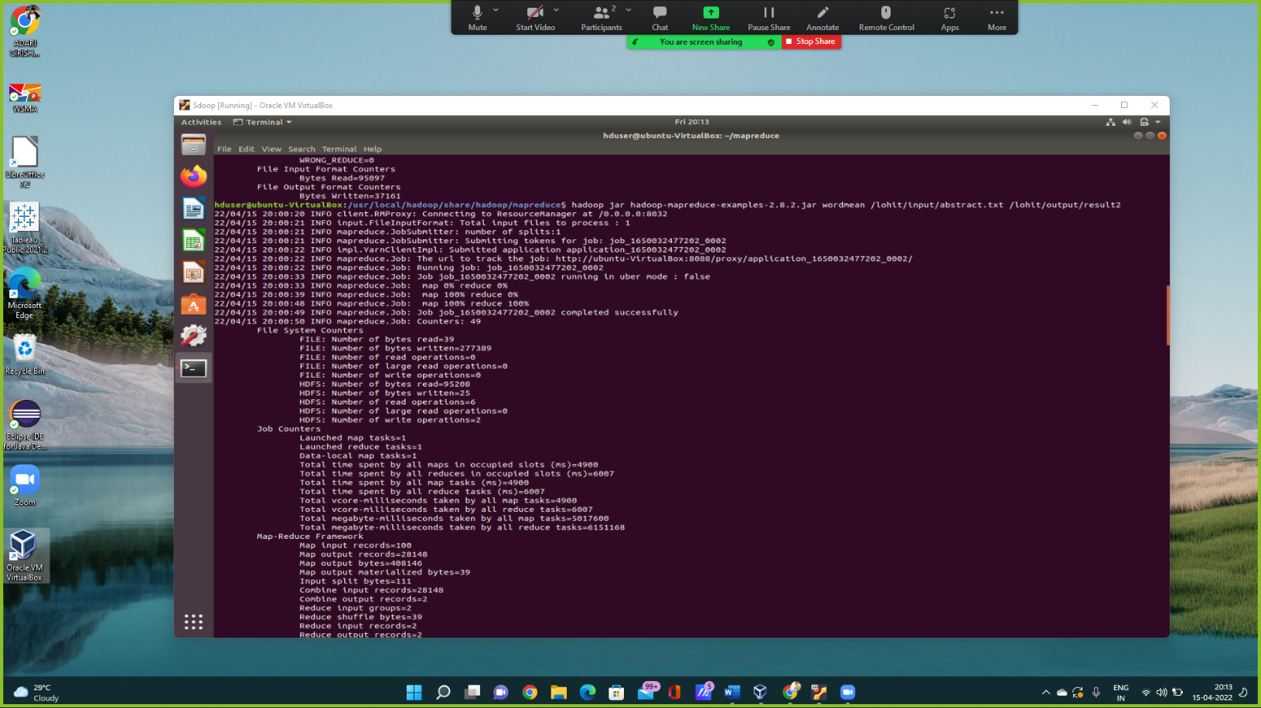

**WORD MEDIAN**

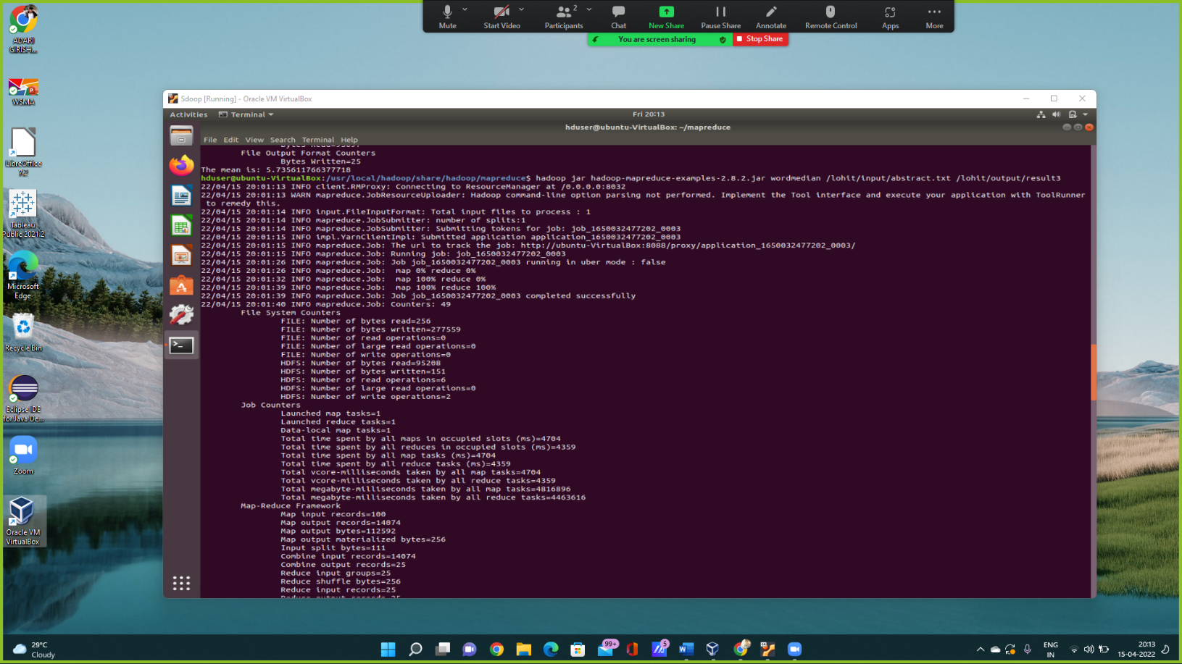

**WORD STANDARD DEVIATION**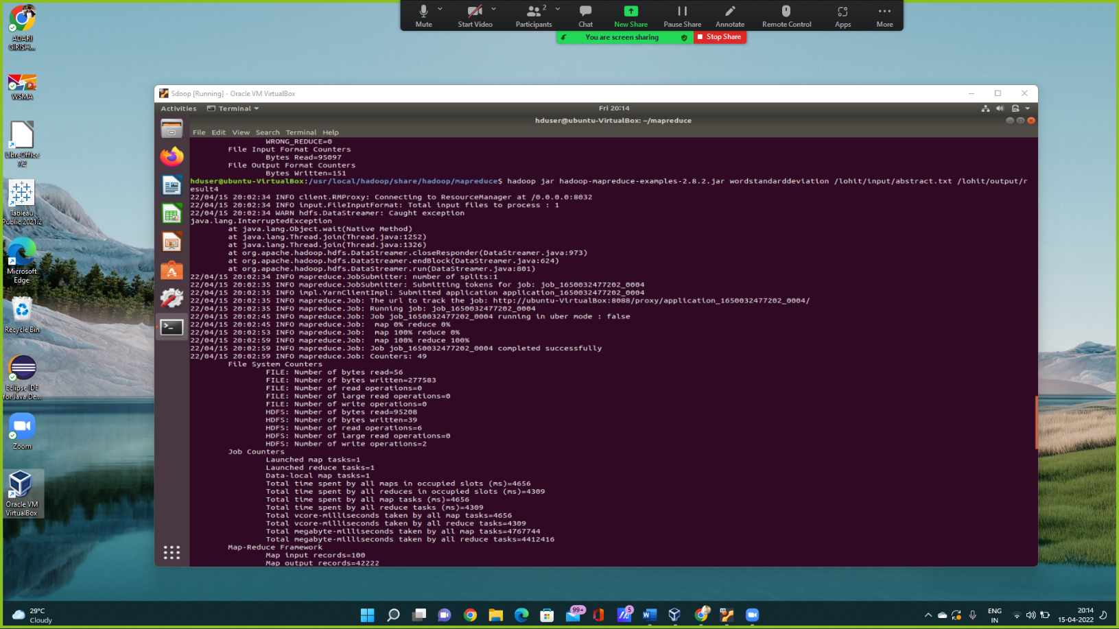

**WORD COUNT AVERAGE**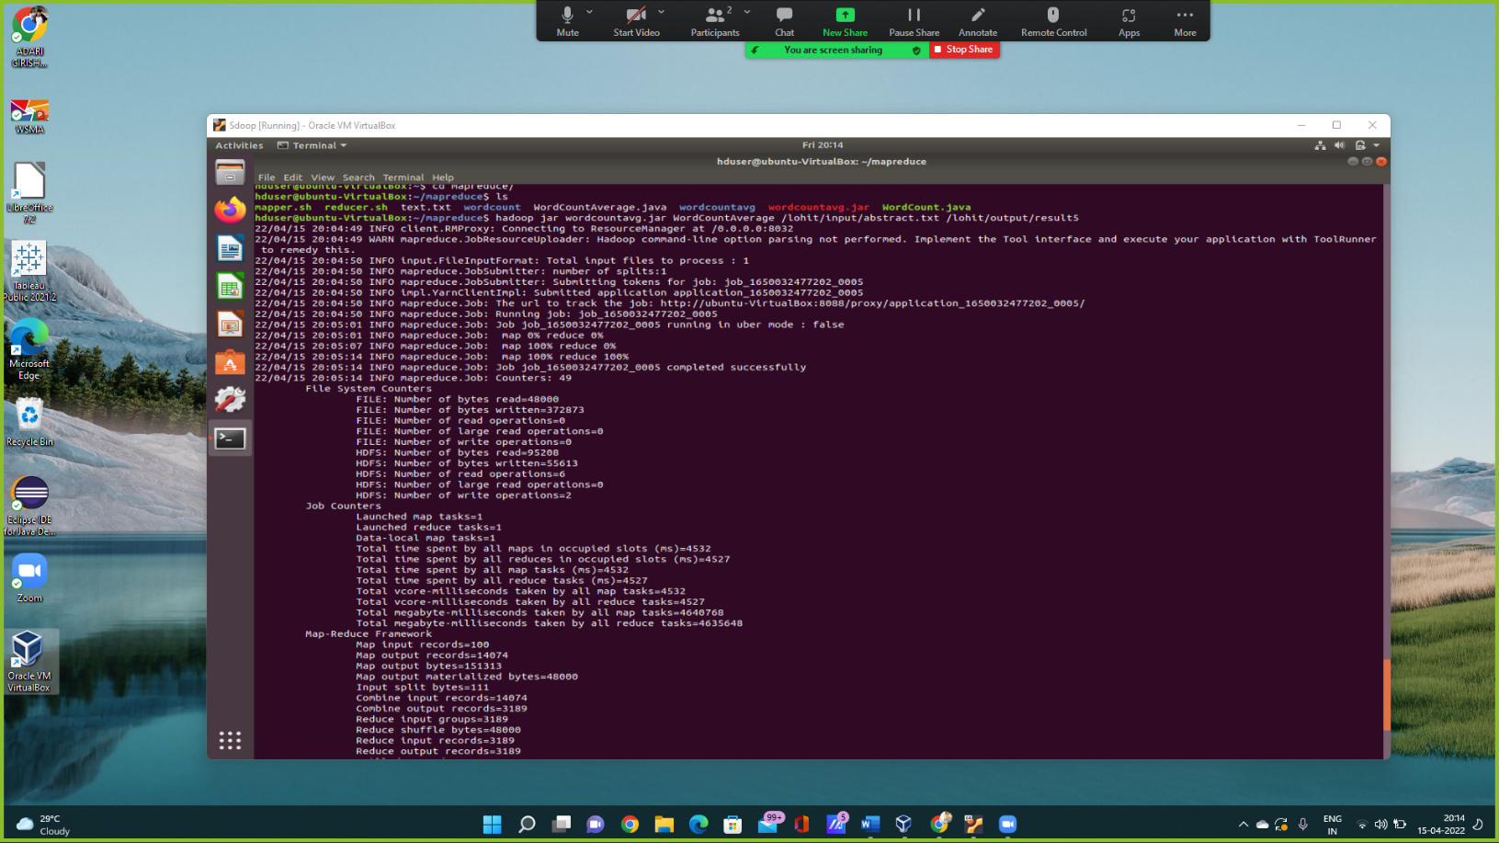

**EXAMPLE OF WORD COUNT**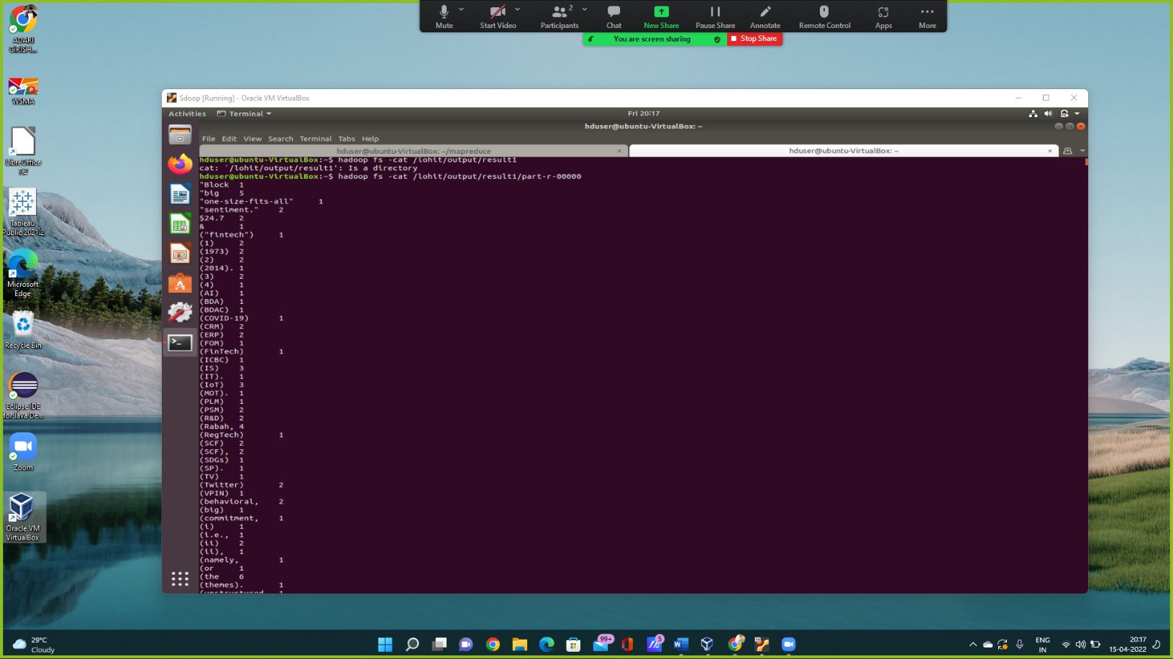

**CONCLUSION**

The data has been collected from different 100 sample abstracts related to big data in Finance these research abstracts are copied and saved in a text file.

We used Map-reduce which reads text files and counts how often the word occurs. The input is the text file, each line of which contains a word and the count of how often it occurred, separated by a tab.

We used to find the word count, word mean, word median, word standard deviation and word count average of the abstract.text file.

Word count: No of words- 378193

Word Mean: 5.735611766377718

Bytes Written=25

Word Median: Bytes Written=151

Median=5

Word Count Avg: Map input records=100

Map output record=14074

Combine input records=14074

combine output records=3189

Bytes Read=95097

Bytes Written=5561

**BIBLIOGRAPHY**

* https://scholar.google.com/
* https://hadoop.apache.org/docs/r2.8.2/hadoop-mapreduce-client/hadoop-mapreduce-client-core/MapReduceTutorial.html
* <https://hadoop.apache.org/docs/r2.8.2/hadoop-mapreduce-client/hadoop-mapreduce-client-core/MapReduceTutorial.html#Example:_WordCount_v1.0>